Time Series Analysis on Data:
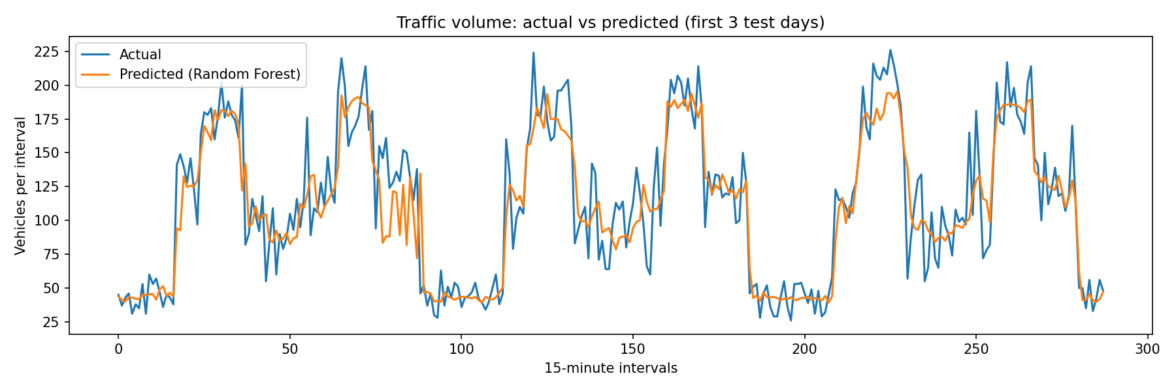
Figure 5: Actual and predicted traffic volume over the first three test days
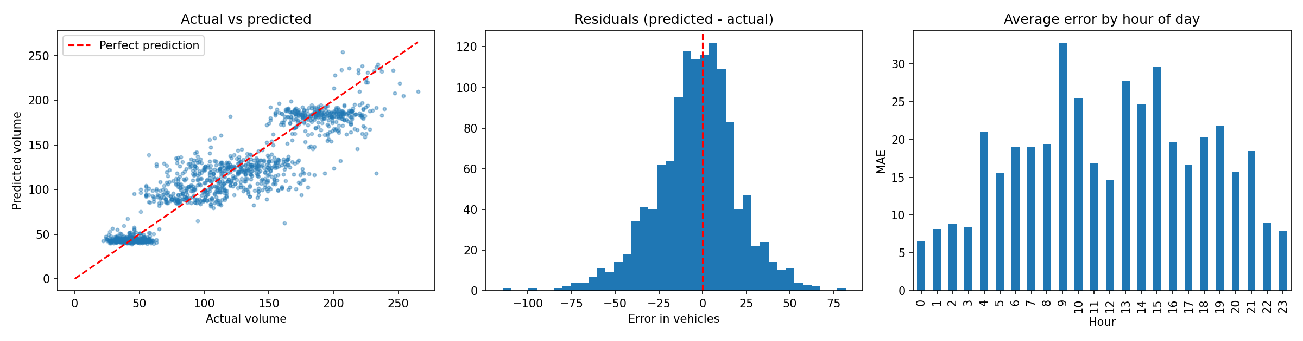
Figure 7: Actual against predicted, residual distribution and error by hour of day
Trend: In figure 5 the model’s prediction relative to actual is 90.1% accurate and there is a pattern of consolidation within the 3 day period. Figure seven displays predicted volume vs actual volume, residuals(predicted-actual) for error in vehicles and average error by hour of day. This helps the model to link the data based on the trends and recommend the safest route with 100% accuracy.
Seasonality; As seen in figure 5 traffic volume decreases during the night and rises during the day. Some other factors that can change traffic volume are holiday seasons traffic and accidents are higher than usual compared to other seasons and the model is able to pick up this deviation.
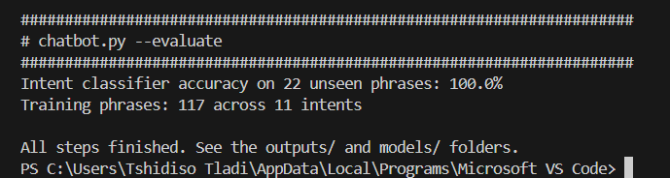
Figure 8: Output of AI model accuracy (100%)

